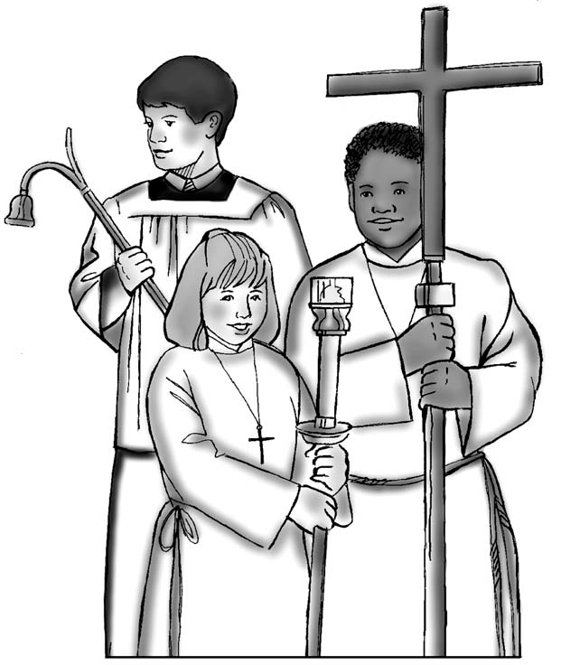
Altar Serving Registration Form

Please complete and return to Peter Keane

Full name of server
Date of birth
School
Parents name
Parents Tel no.
Parents address
Email address

Peter Keane:
Tel: 01543 262935
Email: pk71dg@yahoo.co.uk
www.romancatholiclichfield.co.uk/altar-servers

